Research on a Crime Spatiotemporal Prediction Method Integrating Informer and ST-GCN with STL Decomposition: A Case Study of Four Crime Types in New York City
Redza Nisham
Department of Data Sciences, Penn State University
mkn5378@psu.edu

Abstract—This paper looks at crime prediction in New York City using a hybrid deep learning model that combines the Informer network with a Spatiotemporal Graph Convolutional Network (ST-GCN). The approach was originally developed by Fan et al. for Chicago, and I wanted to see if it would hold up on a bigger, messier city (NYC). The dataset has about 938,000 crime records from 49 NYPD precincts between 2015 and 2020, plus daily weather and holiday information. Four crime types are predicted: assault, robbery, criminal damage, and theft. As a novel enhancement I apply Seasonal Trend decomposition using STL before the input enters the model, inspired by the START framework from Butt et al. The STL enhanced model reaches MAE of 1.64 for assault, 0.60 for robbery, 1.52 for criminal damage, and 1.94 for theft. It cuts theft error by 6.1% compared to the version without STL, and training loss drops by around 20%. Against a standalone LSTM, the hybrid reduces prediction error by 34% to 56% depending on the crime type.
Keywords—crime prediction, Informer, ST-GCN, STL decomposition, spatiotemporal, New York City
I. INTRODUCTION
In this era, figuring out where and when crime is likely to happen is one of the more practical uses of data science in public safety. Even if police can get even a day or two of warning, they can shift resources accordingly. That idea has driven a lot of research, and deep learning has made it more doable than it used to be.
NYC is a pretty interesting place for this kind of study because there is over 8 million people across five boroughs, and each borough feels almost like its own city. Crime in midtown Manhattan doesn't look anything like crime in the South Bronx, or eastern Queens. Any model hoping to predict NYC crime needs to handle both the time side (how things change day to day) and the space side (how crime in one place relates to crime next door).
There were many works had been done before regarding this but mostly all of them relied on statistical tools like ARIMA or deep learning models like LSTM. Butt et al. [1] and Srivastava et al. [2] both point out that these focus mostly on time and miss the spatial side. Graph Neural Networks help with that by treating districts as nodes connected by edges based on actual geography. Fan et al. [3] used this idea in their ST-GCN module, and paired it with Informer on the temporal side to build a hybrid model that they tested on 22 Chicago police districts.
But whether this works in a different city is still a question. Butt et al. [1] tried their START model on three cities and saw performance vary a lot. Srivastava et al. [2] admit their single city evaluation limits what they can claim. This paper takes the Fan et al. [3] architecture and applies it to NYC with about 938,000 crime records from 2015 to 2020. I also add STL decomposition as a preprocessing step, borrowing the idea from Butt et al. [1], to deal with the non stationary patterns in the data. As you can see, NYC is much harder than Chicago in a few ways: 49 precincts instead of 22, more crime overall, and more variety between neighbourhoods. The main contributions are (1) adapting the hybrid model to NYC's 49 precinct layout, (2) adding STL decomposition, (3) showing the enhanced model cuts theft error by 6.1%, and (4) comparing NYC and Chicago results side by side.
II. LITERATURE REVIEW
A. Statistical and Deep Learning Approaches
Crime prediction started in statistical time series modeling. ARIMA and exponential smoothing were popular because they're simple, but Butt et al. [1] note that they assume the data is stationary, which crime data isn't. Vector autoregression (VAR) helps a bit by handling multiple variables, but still can't handle nonlinear patterns well. Classical ML models like random forests need heavy feature engineering and ignore spatial structure, as Srivastava et al. [2] said.
Here is when deep learning changed how things work. LSTM can surely learn long sequences but it has trouble with very long ones, and errors pile up when predictions feed back into the next step. CNNs and Conv-LSTM can learn spatial structure on a grid, but as Srivastava et al. [2] said, forcing irregular district boundaries onto a regular grid flattens the real layout of a city. That's what pushed researchers toward graph based models.
B. Graph Neural Networks and Transformers
GNNs treat spatial units as nodes with edges based on actual adjacency. As we can see where Fan et al. [3] built their ST-GCN module on the standard GCN formulation, stacking GCN layers inside a residual network that separately handles proximity, periodic, and trend features. Srivastava et al. [2] took a different spatial route with Graph Attention Networks (GATs) in DA-GNN, letting the model learn which neighbours matter most instead of treating them equally. This approach can be said as very successful because in their paper, they stated that they reached an MAE of 0.78 on Chicago.

Transformers changed time series forecasting by using self attention to look at all time steps at once and the Informer made this practical for long sequences through ProbSparse self attention. Fan et al. [3] picked Informer for their temporal module because of these, and also because of the probability of getting over 30% error reduction versus LSTM in other domains. Butt et al. [1] built START on a similar transformer foundation but paired it with VAR instead of a graph network, and applied STL decomposition. START was tested on NYC, Chicago, and LA, which makes it one of the few multi city evaluations out there. For hourly NYC predictions, START got a MAPE of 0.43 and MAE of 11.21.
C. The Informer Plus ST-GCN Hybrid
The model I'm replicating was originally from Fan et al. [3]. It has three pieces: an ST-GCN module that pulls spatial features at three time scales, an Informer module that handles temporal patterns, and a fusion layer that combines both outputs for the final prediction. They trained on about around 320,000 crime records from 2015 to 2020 using weather and temporal features. They reached MAE of 0.73 for assault, 1.36 for theft, 1.03 for robbery, and 1.05 for criminal damage, beating every baseline they tested. What's still not clear from their work is how well it transfers across cities, which is where this paper picks up.
III. NOVELTY AND CONTRIBUTIONS
The core arcihtecture follows Fan et al. [3], but two things are different. First, cross city generalizationwhich is the first study I'm doing from the hybrid model Fan et al. produces, transferring it to a city other than Chicago which is NYC. NYC has 49 active precincts across five boroughs with very different characteristics, against Chicago's 22 more uniform districts. Fan et al. [3] flagged cross regional testing as future work in their conclusion, and Butt et al. [1] and Srivastava et al. [2] both mentioned similar limits.
Second, STL decomposition as preprocessing. The idea comes from Butt et al. [1], who used STL in START and reported 10% to 15% improvement. Crime data is non stationary by nature, with weekly cycles, seasonal patterns, and longer term trends. The original Fan et al. [3] model feeds raw counts directly into the network, so the model has to learn those patterns on its own. By applying STL, first I split each precinct's series into trend, seasonal, and residual components, then feed the trend plus residual to the model. This strips out the predictable weekly stuff and lets the model focus on the harder residual variation. In a much simpler way of saying, I don’t want the model to overthink and waste their time in focusing on the things that is very obvious. I also used a period of 7 days to capture weekly seasonality, with robust fitting for outliers, applied independently per precinct and crime type.
IV. MATERIALS AND METHODS
A. Data Collection
In total there are three types of data being collected, all covering from January 2015 to March 2020. The crime data came from the NYC Open Data Portal via the Socrata API, filtered to four categories which are assault (felony assault and assault 3), robbery, criminal damage (criminal mischief), and theft (petit larceny, grand larceny, grand larceny of motor vehicle). After cleaning, there are 938,414 records across 49 precincts. The weather data on the other hand came from the Open Meteo API using Central Park coordinates, including daily temperature, humidity, wind speed, and precipitation. I computed all the derived features following Fan et al. [3], which are apparent temperature, wet bulb temperature, water vapor pressure, and discomfort index (formulas in Appendix A). Temporal features include binary flags for weekends and U.S. federal holidays, which is a 30 day rolling averages of crime counts, and the previous day's count. Table I below has the full feature list. In addition, exploratory visualizations are all in Appendix C.
TABLE I Features Used in the Model
Feature | Type | Description
Weekend | Boolean | 1 if Sat/Sun, 0 otherwise
Holiday | Boolean | 1 if federal holiday
Temperature | Float | Daily mean temp (C)
Humidity | Float | Relative humidity (%)
Wind Speed | Float | Max wind speed (m/s)
Precipitation | Float | Daily total (mm)
Discomfort Index | Float | Derived weather metric
Apparent Temp | Float | Feels like temperature
Rolling Avg | Float | 30 day crime average
Prev Day Count | Int | Yesterday's crime count
B. Precinct Graph
I downloaded the official precinct boundary shapefiles from NYC's ArcGIS service and checked which precincts share a border. The logic is simple, if two precincts touch or come within about 100 meters of each other, I drew an edge. The graph on the other hand has 49 nodes and 99 edges, so about aorund 4 neighbours per precinct on average. Self loops were added so that each precinct includes its own data during convolution. Fig. 1 below shows the result.
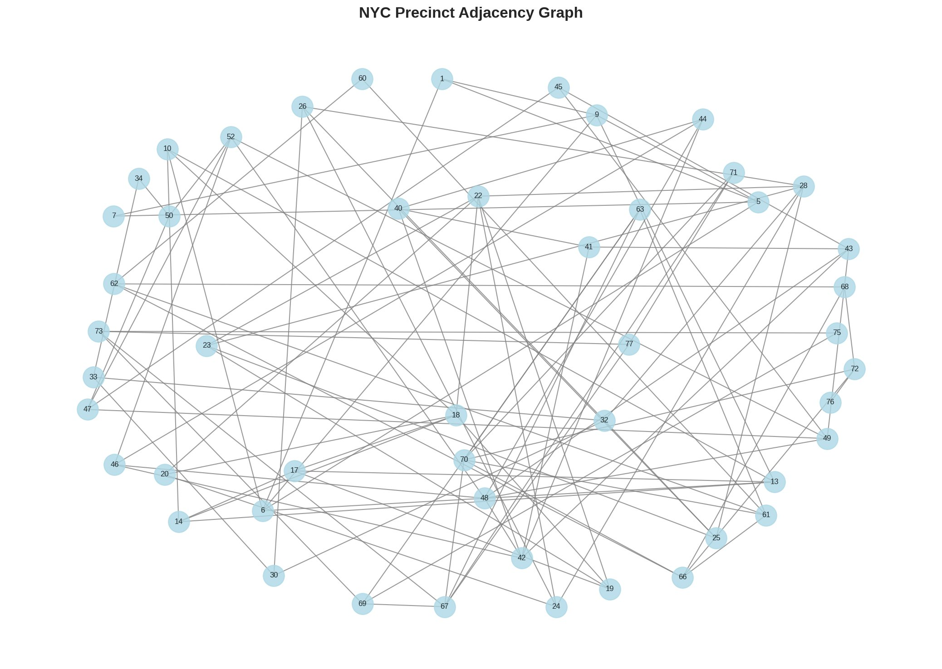
Fig. 1. NYC precinct adjacency graph (49 nodes, 99 edges).
C. Model Architecture and Training
My model follows Fan et al. [3] with three modules. First, the ST-GCN module applies graph convolutions on the adjacency matrix across three branches, proximity (recent days), periodic (data from further back), and trend (earliest data in the window). Each uses stacked residual GCN blocks and the outputs are fused through a linear layer (full equation in Appendix B). While on the other side, the Informer module handles temporal patterns with a Transformer encoder using self attention and convolutional distillation, processing all precincts in parallel. Outputs produced from both modules are concatenated and passed through fully connected layers with ReLU and 10% dropout to produce the predicted crime counts.
NAdam optimizer was used for the training, with learning rate 0.001 and cosine annealing. (Batch size 32, lookback window 7 days, training from 2015 to 2019 (1,826 days), testing using data from January 1 until January 7, 2020 (7 days)). Early stopping with patience 20 was required for me to prevent overfitting from occuring. In addition, the model has around 239,000 parameters. I evaluated all the outputs produced by using their MAE, RMSE, and R squared. Fig. 2 below shows the training loss.
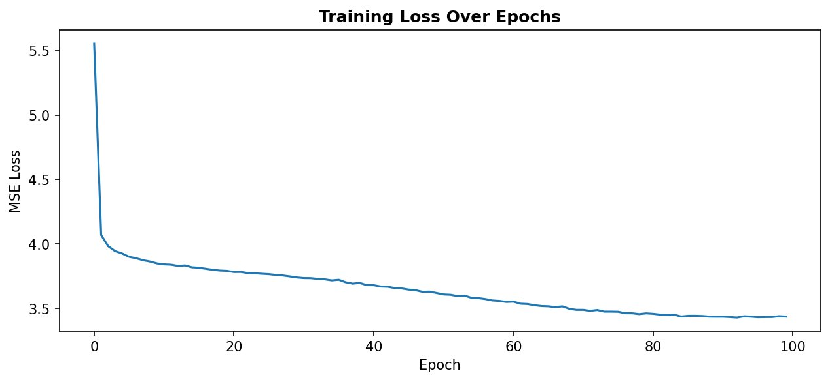
Fig. 2. Training loss curve. The deseasonalized input from STL makes the loss easier to minimize.
V. RESULTS
A. Baseline Comparison
Tables II through V give per crime type results. The bottom row is the final STL enhanced model.
TABLE II Model Comparison for Assault
Model | MAE | RMSE | R²
Linear Regression | 1.53 | 2.11 | 0.41
Ridge Regression | 1.53 | 2.11 | 0.41
Random Forest | 1.58 | 2.21 | 0.35
LSTM | 2.47 | 3.53 | -0.65
Informer+ST-GCN | 1.63 | 2.28 | 0.31
Informer+ST-GCN+STL (Ours) | 1.64 | 2.31 | 0.29
TABLE III Model Comparison for Theft
Model | MAE | RMSE | R²
Linear Regression | 1.80 | 2.36 | 0.51
Ridge Regression | 1.80 | 2.36 | 0.51
Random Forest | 1.83 | 2.39 | 0.50
LSTM | 4.41 | 5.51 | -1.68
Informer+ST-GCN | 2.06 | 2.63 | 0.39
Informer+ST-GCN+STL (Ours) | 1.94 | 2.45 | 0.47
TABLE IV Model Comparison for Robbery
Model | MAE | RMSE | R²
Linear Regression | 0.60 | 0.83 | 0.23
Ridge Regression | 0.60 | 0.83 | 0.23
Random Forest | 0.62 | 0.84 | 0.21
LSTM | 0.62 | 0.97 | -0.06
Informer+ST-GCN | 0.61 | 0.84 | 0.22
Informer+ST-GCN+STL (Ours) | 0.60 | 0.82 | 0.24

TABLE V Model Comparison for Criminal Damage
Model | MAE | RMSE | R²
Linear Regression | 1.45 | 3.68 | 0.13
Ridge Regression | 1.45 | 3.69 | 0.13
Random Forest | 1.72 | 5.30 | -0.80
LSTM | 1.83 | 4.23 | -0.15
Informer+ST-GCN | 1.51 | 3.67 | 0.14
Informer+ST-GCN+STL (Ours) | 1.52 | 3.82 | 0.06
There are couple things that taking me out by surprise. Firstly, LSTM performs poorly everywhere, where most of them predicted with negative R squared values, meaning it's worse than just guessing the average. That's probably because errors pile up as each day's prediction gets fed back as input. Next, linear and ridge regression do surprisingly well on assault and theft, maybe because of the fact that the rolling average and previous day features are strong predictors where simple models can easily exploit. Latsly, for criminal damage, the original Informer plus ST-GCN model gets the best R squared (0.14) and lowest RMSE (3.67).
B. Effect of STL Decomposition
Table VI pulls all the MAE results into one view with the STL enhanced model on the bottom row.
TABLE VI Complete Comparison Including STL Enhancement (MAE)
Model | Assault | Robbery | Crim.Dmg | Theft
Linear Regression | 1.53 | 0.60 | 1.45 | 1.80
Ridge Regression | 1.53 | 0.60 | 1.45 | 1.80
Random Forest | 1.58 | 0.62 | 1.72 | 1.83
LSTM | 2.47 | 0.62 | 1.83 | 4.41
Informer+ST-GCN | 1.63 | 0.61 | 1.51 | 2.06
Informer+ST-GCN+STL (Ours) | 1.64 | 0.60 | 1.52 | 1.94
My model gives a clear win on theft, dropping MAE from 2.06 to 1.94 (6.1% reduction) and bumping R squared from 0.39 to 0.47. Robbery improved a bit too while assault and criminal damage barely moved. Theft is also the highest volume crime in our data with almost 800,000 records (from 938,000), and high volume categories tend to have stronger and more consistent seasonal patterns, which STL is built to remove. Training loss tells the same story where the original model converged at 3.36, while my STL version converged at 2.70, that is a 20% improvement which is pretty huge.
C. Spatial and Temporal Performance
Aggregate metrics only go so far. Fig. 3 below shows MAE per precinct for each crime type, and errors are not uniform obviously. Higher volume precincts in Manhattan and the Bronx will surely have larger absolute errors, though proportionally accuracy is similar. On the other hand, quieter outer borough precincts have smaller errors overall.
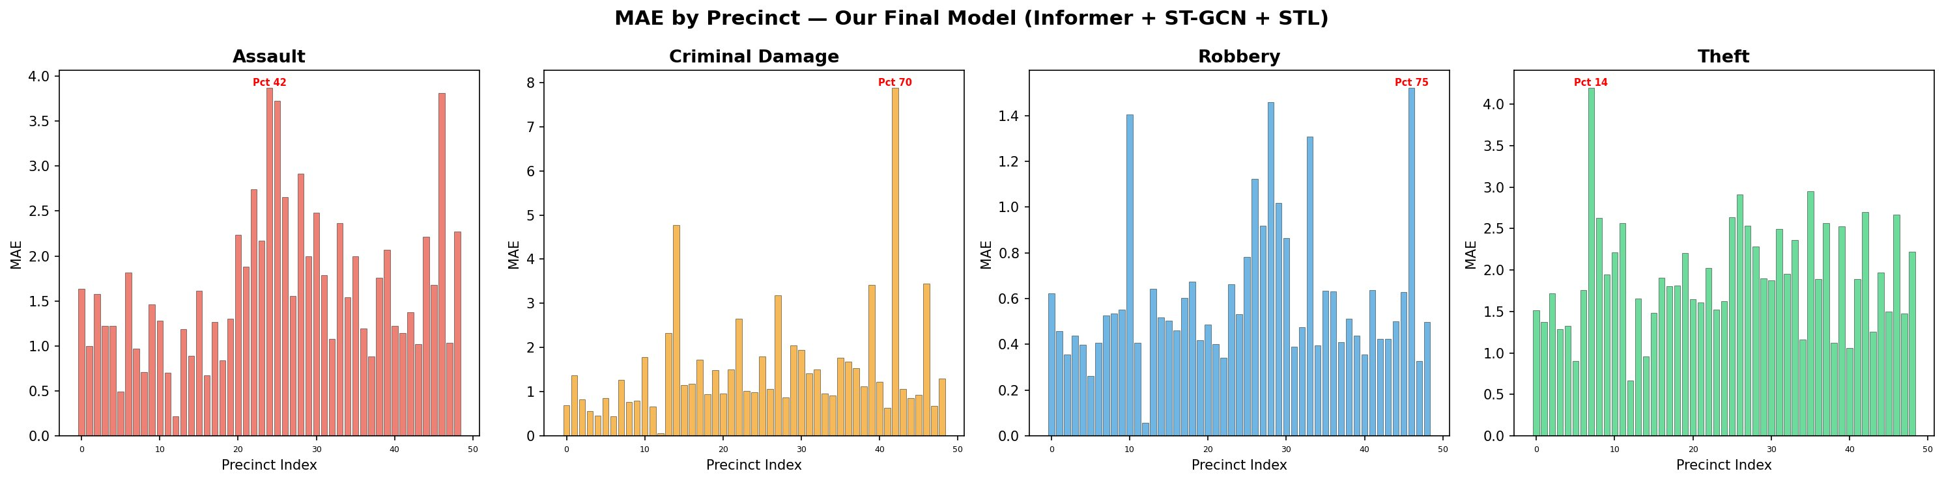
Fig. 3. MAE across the 49 NYC precincts by crime type.
Fig. 4 shows actual vs predicted daily counts for theft across six sample precincts in the test week. Eventhough the model can picks up the general trend but it also tends to underpredict on days with unusually high spikes. The other time series for the other three crime types are all attached in Appendix C.
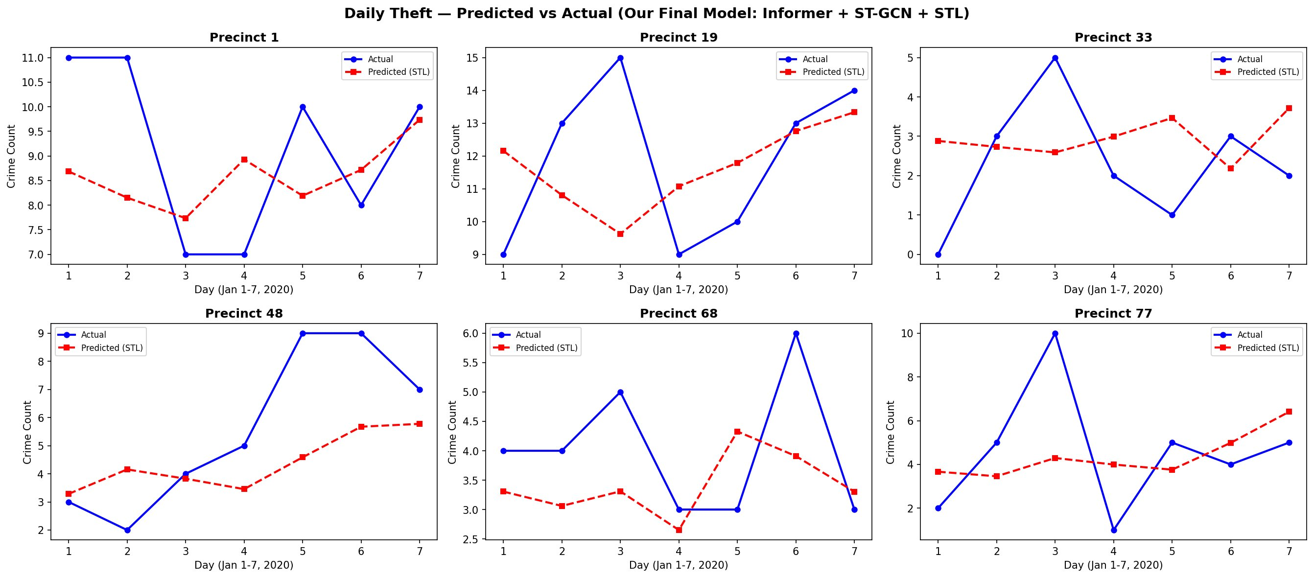
Fig. 4. Daily theft predictions vs actual counts for six sample precincts (Jan 1-7, 2020).
VI. DISCUSSION
The main takeaway that we can conclude is that the Informer plus ST-GCN hybrid do works on NYC plus the STL gives a real boost for high volume crime types. The enhanced model beats LSTM by a wide margin across all four crime types, cutting MAE by 34% for assault, 17% for criminal damage, 3% for robbery, and 56% for theft.
Comparing to Fan et al. [3] for Chicago is quite interesting. Their MAE values were 0.73 for assault, 1.36 for theft, 1.03 for robbery, and 1.05 for criminal damage. Our NYC numbers are a bit higher in most cases (but still stays within noise), which makes sense because if we look back at the comparison, NYC have 49 precincts instead of 22, more total crime, and five very different boroughs creating more diverse patterns. One supirsing result is that our robbery MAE of 0.60 is actually much lower than Chicago's 1.03, which suggests the model picks up on robbery patterns pretty well in NYC.
One thing that also caught me by surprise was how competitive simpler regression ended up being. That's partly because the rolling average and previous day count features already carry a lot of signal. Moreover, I do expect the hybrid's advantage to grow with longer prediction horizons and richer spatial data. Plus, the STL results lined up with Butt et al. [1], who reported 10% to 15% improvement from STL in START where our 6.1% theft improvement sits in this range. The practical takeaway is that STL preprocessing is mostly worth doing for crime categories with the most data and the strongest seasonal patterns.
Of course there are limitations. First and foremost, the test period is only 7 days, so a longer window would give a more complete picture. Plus there is no socioeconomic features were used. The adjacency graph is also static, but crime spillover can obviously shift. This was also an offline evaluation, not taking place in real time. Furthermore, predictive policing models can also reinforce biases in historical data, so any real use should be framed as decision support rather than an enforcement tool, as Srivastava et al. [2] emphasized.
VII. CONCLUSION AND FUTURE WORK
This paper shows that the Informer plus ST-GCN hybrid model can possibly be adapted from Chicago to NYC. Using about around 938,000 records from 49 precincts, the STL enhanced version reaches an MAE of 1.64 for assault, 0.60 for robbery, 1.52 for criminal damage, and 1.94 for theft. STL do reduced theft error by 6.1% and improves training loss by 20%, at the same time confirming that handling non stationarity explicitly helps. The model consistently outperforms LSTM, confirming the value of combining graph based spatial modeling with transformer based temporal modeling.
For my future work, I want to swap GCN for GATs (as in Srivastava et al. [2]) because this could let the model learn which neighbours matter most instead of treating all the adjacent precints equally. I also believed by adding socioeconomic features like income, demographics, and points of interest can also capture underlying crime drivers. Lastly, cross city transfer learning where we first pre-trained the data on Chicago and then fine-tuning them on NYC, could leverage shared urban patterns. Dynamic adjacency graphs on the other hand, plus longer prediction horizons, would instantly push the model closer to real world use. All the codes and notebooks are available at [4].
APPENDIX A: DERIVED WEATHER FEATURE FORMULAS
Following Fan et al. [3], the derived weather features were computed using the formulas below. Let T denote air temperature in degrees Celsius, RH denote relative humidity in percent, and V denote wind speed in meters per second.
The water vapor pressuree is given by:
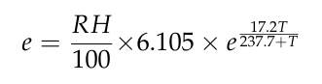(A.1)
The apparent temperature AT is computed as:
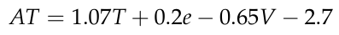(A.2)
The wet bulb temperature Tw uses the Stull approximation:
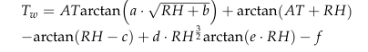(A.3)
Finally, the discomfort index DI is the average of Tw and AT:
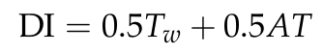 (A.4)
APPENDIX B: GCN LAYER EQUATION
The graph convolution operation used in the ST-GCN module follows the standard GCN formulation:
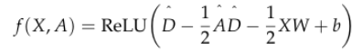(B.1)
Here, X is the input feature matrix, Ã = A + I is the adjacency matrix with self-loops added, D̃ is the diagonal degree matrix derived from Ã, W is the learnable weight matrix, b is the bias vector, and ReLU is the rectified linear activation. This formulation lets each node aggregate information from its neighbours in a single matrix operation.
The STL decomposition splits each crime time series Y_{t} into three components:
Y_{t} = T_{t} + S_{t} + R_{t} (B.2)
where T_{t} is the trend component, S_{t} is the seasonal component (with period 7 for weekly cycles), and R_{t} is the residual. The model receives T_{t} + R_{t} as input, which removes the predictable weekly seasonality.
APPENDIX C: ADDITIONAL VISUALIZATIONS
This appendix has extra figures supporting the analysis in the main paper, including exploratory analysis of NYC crime patterns and time series predictions for the three crime types not shown in the main results.
A. Exploratory Data Analysis
Fig. C.1 shows the daily crime counts for all four crime types across the full period. Theft is consistently the most common, followed by assault, criminal damage, and robbery. Weekly fluctuations and seasonal trends are visible.
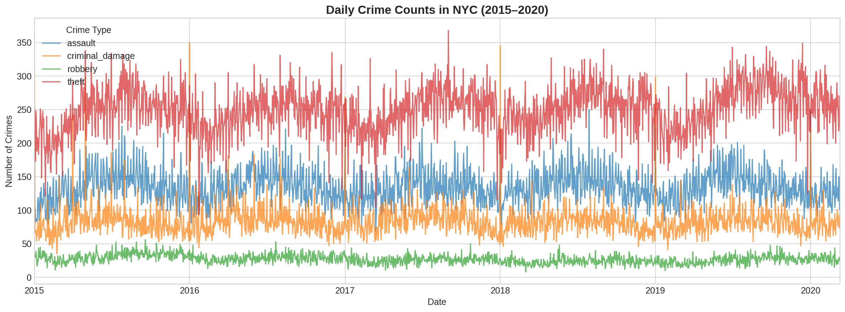
Fig. C.1. Daily crime counts in NYC by type, 2015 to 2020.
Fig. C.2 shows total counts for each crime type. Theft dominates with over 472,000 records.
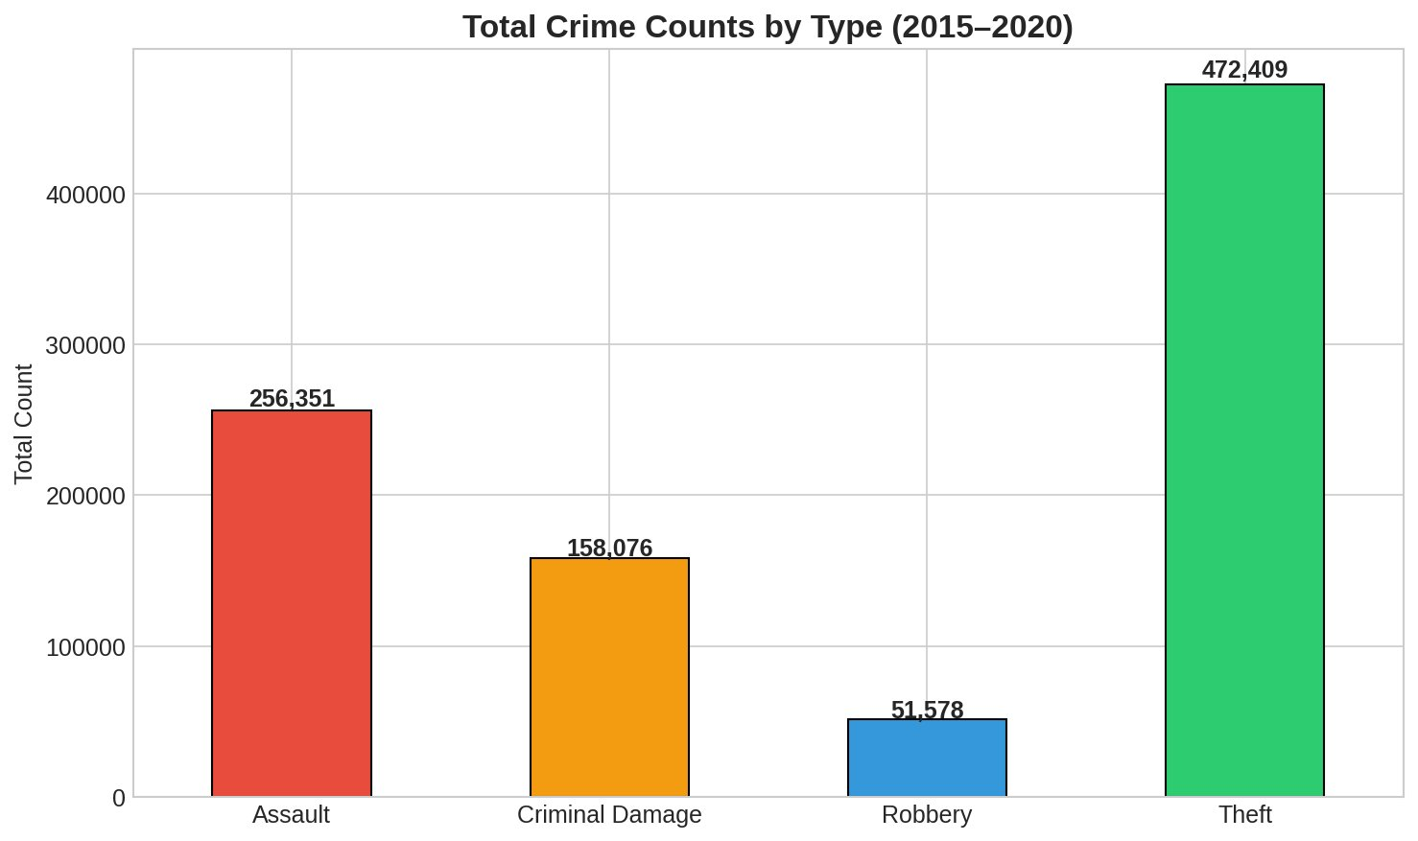
Fig. C.2. Total crime counts by type from 2015 to 2020.
Fig. C.3 shows monthly seasonality. Assault and theft both peak in the summer months, while criminal damage shows a smaller seasonal effect.
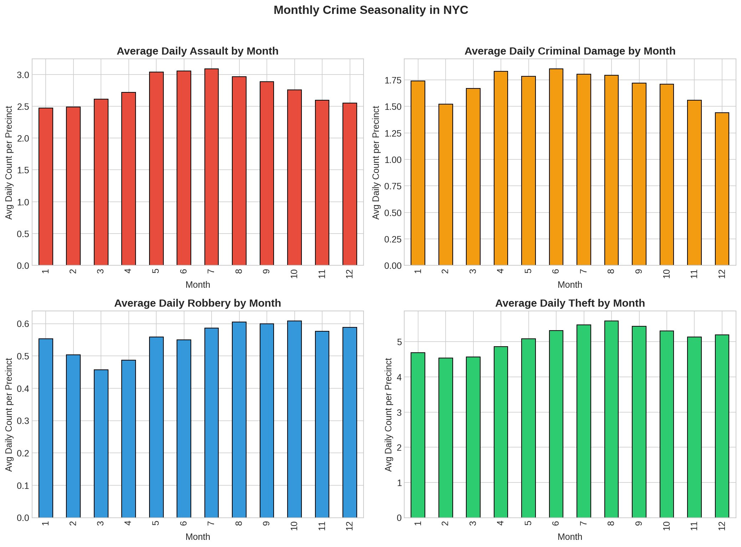
Fig. C.3. Average daily crime count per precinct by month.
Fig. C.4 shows day of week patterns. Assault is higher on weekends, while theft peaks on Fridays. These weekly patterns are exactly what motivated using STL with period 7.
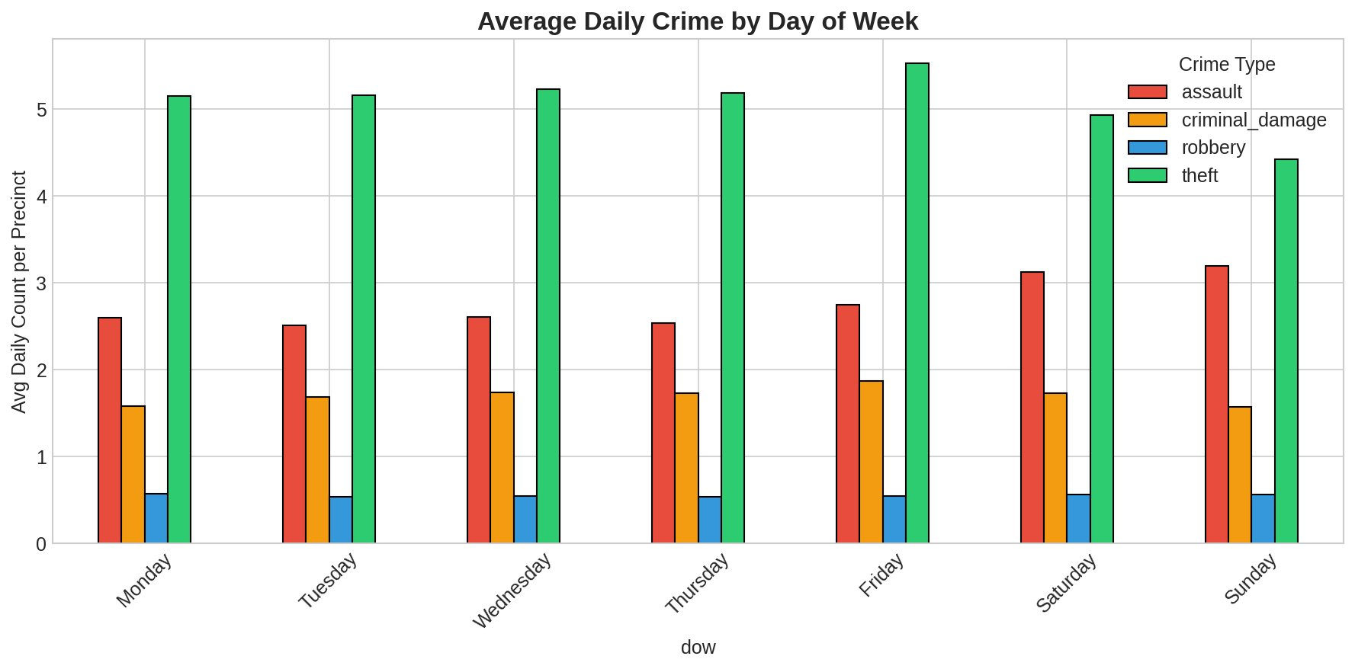
Fig. C.4. Average daily crime count per precinct by day of week.
Fig. C.5 shows the top 20 precincts by total crime volume. Precinct 75 (East New York, Brooklyn) has the highest total.
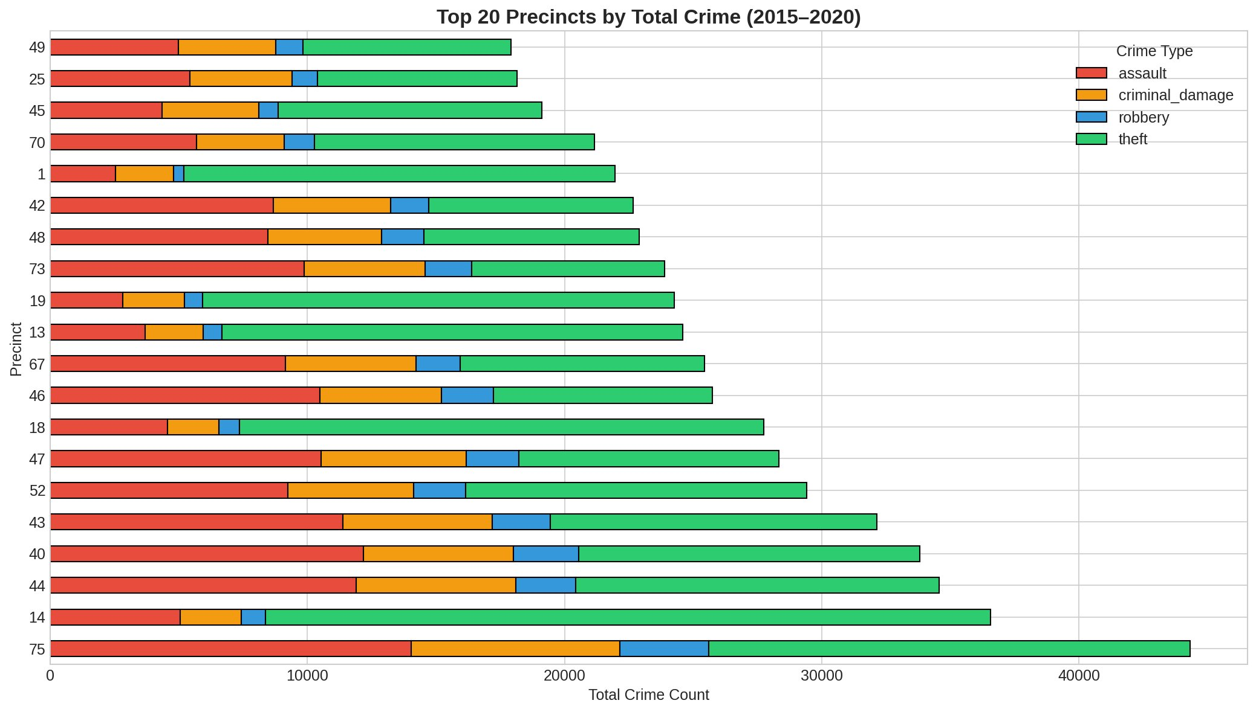
Fig. C.5. Top 20 precincts by total crime volume from 2015 to 2020.
Fig. C.6 is the correlation matrix between crime types and weather features. Temperature and discomfort index have the strongest correlations with assault (0.47, 0.46) and theft (0.47, 0.45).
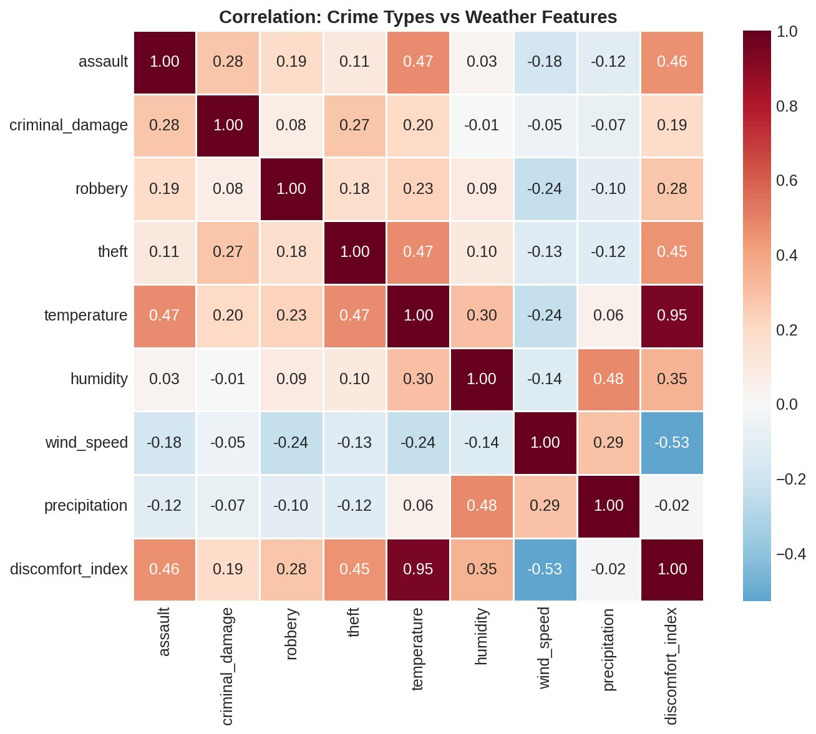
Fig. C.6. Correlation between crime types and weather features.
B. Time Series Predictions for Other Crime Types
Figs. C.7 through C.9 show time series plots for assault, criminal damage, and robbery, matching the theft plot from Fig. 4.
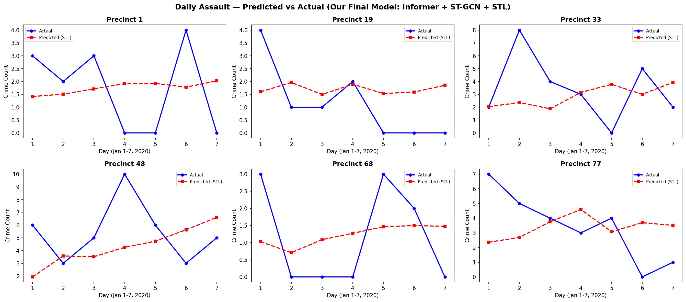
Fig. C.7. Daily assault predictions vs actual counts for six sample precincts (Jan 1-7, 2020).
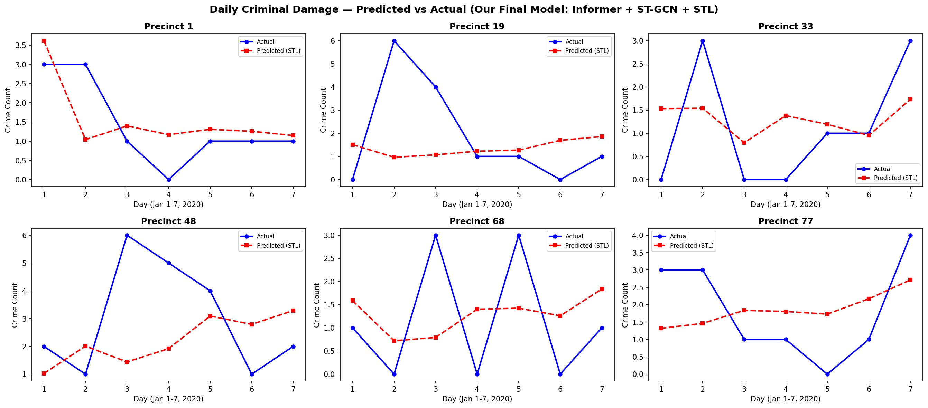
Fig. C.8. Daily criminal damage predictions vs actual counts for six sample precincts (Jan 1-7, 2020).
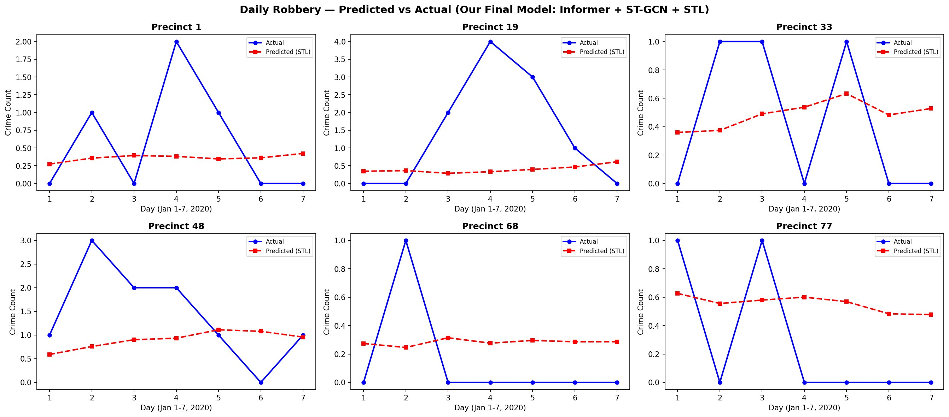
Fig. C.9. Daily robbery predictions vs actual counts for six sample precincts (Jan 1-7, 2020).
C. Aggregate Predicted vs Actual by Precinct
Figs. C.10 through C.13 compare total predicted and actual crime counts across the top 20 precincts for the test week.
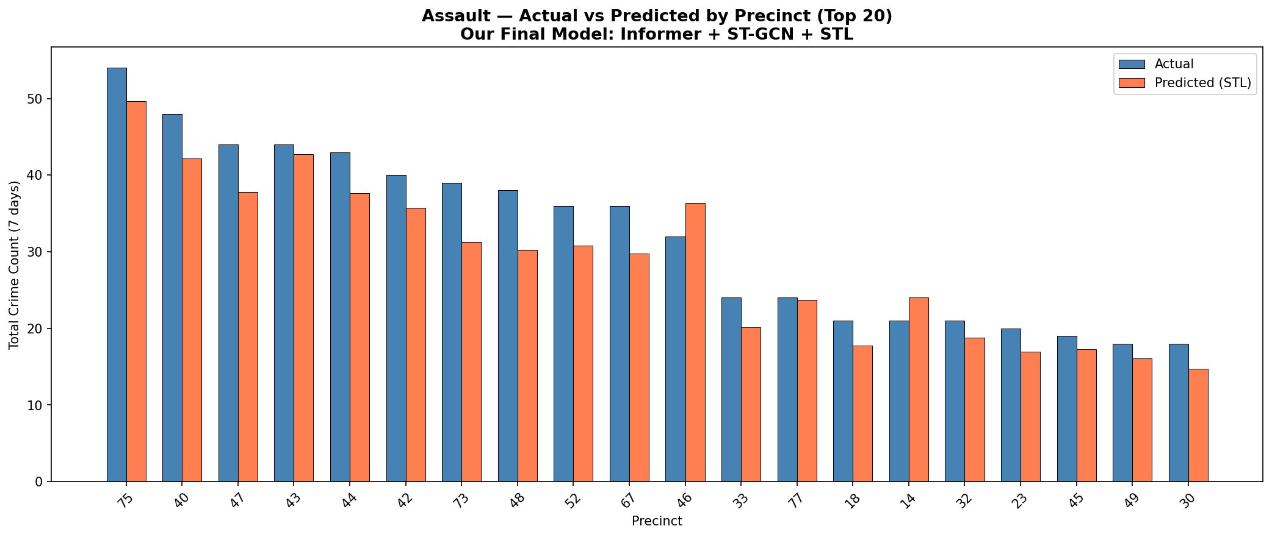
Fig. C.10. Assault: actual vs predicted by precinct (top 20).
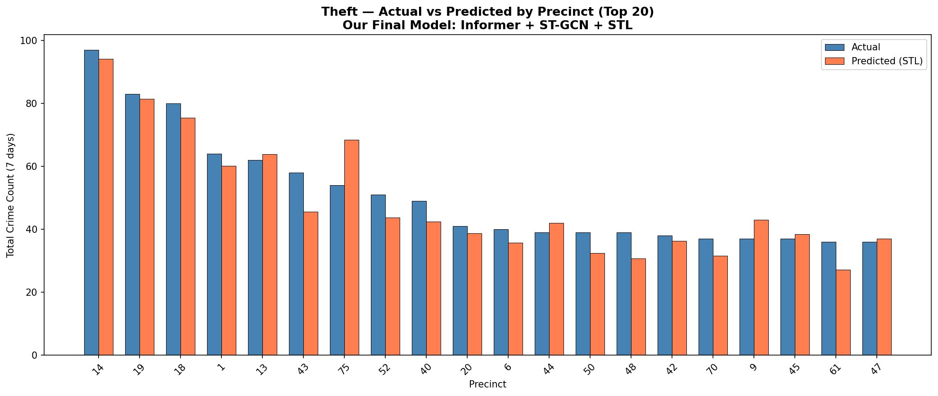
Fig. C.11. Theft: actual vs predicted by precinct (top 20).
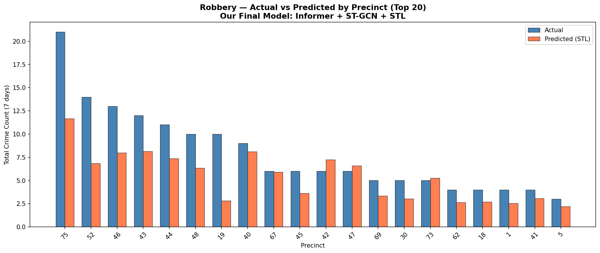
Fig. C.12. Robbery: actual vs predicted by precinct (top 20).
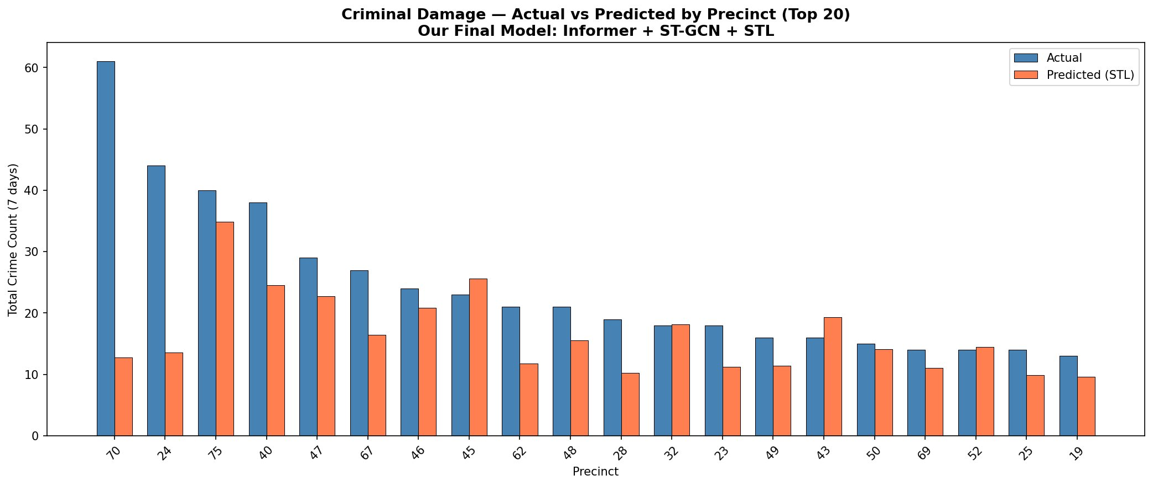
Fig. C.13. Criminal damage: actual vs predicted by precinct (top 20).
REFERENCES
[1] U. M. Butt, S. Letchmunan, M. Ali, and H. H. R. Sherazi, "START: A spatiotemporal autoregressive transformer for enhancing crime prediction accuracy," IEEE Trans. Comput. Soc. Syst., vol. 12, no. 6, pp. 4650–4664, Dec. 2025.
[2] M. Srivastava, S. Raj, and J. Nithyashri, "Dual-attention graph neural networks for spatiotemporal crime forecasting and patrol optimization," in Proc. 7th Int. Workshop Artif. Intell. Educ., 2025, pp. 416–420.
[3] Y. Fan, X. Hu, and J. Hu, "Research on a crime spatiotemporal prediction method integrating Informer and ST-GCN: A case study of four crime types in Chicago," Big Data Cogn. Comput., vol. 9, no. 179, Jul. 2025.
[4] R. Nisham, "NYC Crime Spatiotemporal Prediction," GitHub repository, 2026. [Online]. Available: https://github.com/redzanisham/nyc-crime-spatiotemporal-prediction

